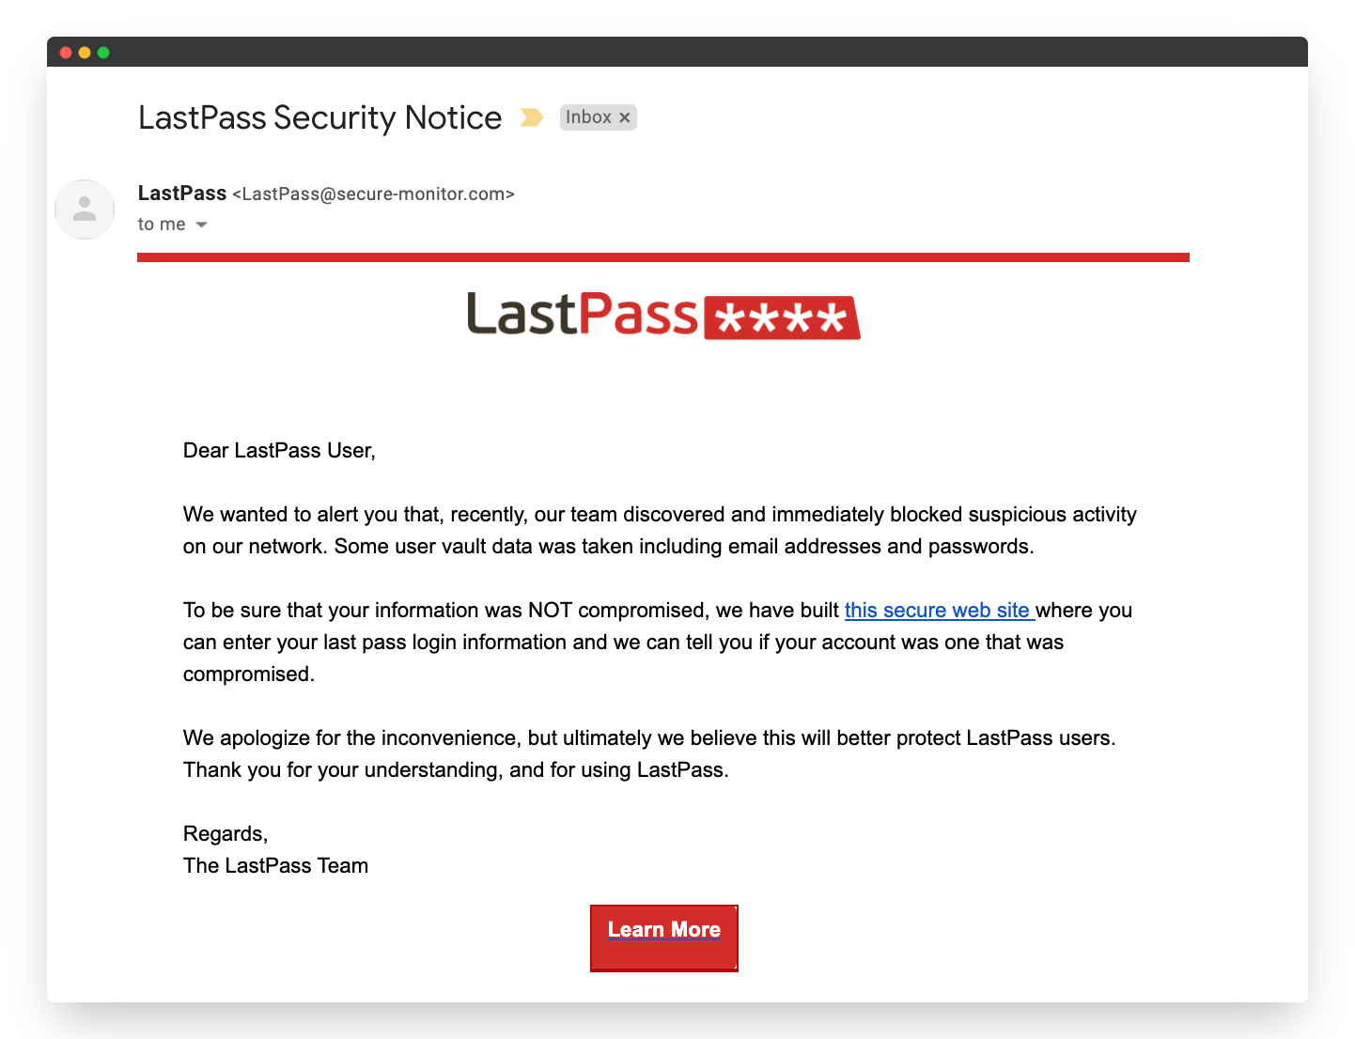

Sender email address : [LastPass@secure-monitor.com](mailto:LastPass@secure-monitor.com)

Suspicious Links: this secure web site

Urgent or threatening language: We wanted to alert you that

Phishing traits: in this email the language of email is seem to be urgent and it ask user to click particular link where it ask whether it is true or not.